32.52: a) The momentum transfer is always greatest when reflecting surfaces are used (consider a ball colliding with a wall⎯the wall exerts a greater force if the ball rebounds rather than sticks). So in solar sailing one would want to use a reflecting sail.
b) The equation for repulsion comes from balancing the gravitational force and the force from the radiation pressure. As seen in Problem 32.51, the latter is:
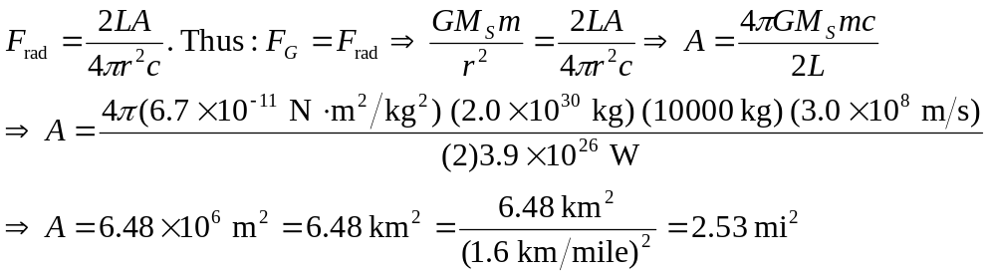
c) This answer is independent of the distance from the sun since both the gravitational force and the radiation pressure go down like one over the distance squared, and thus the distance cancels out of the problem.

